**CS673 Software Engineering** 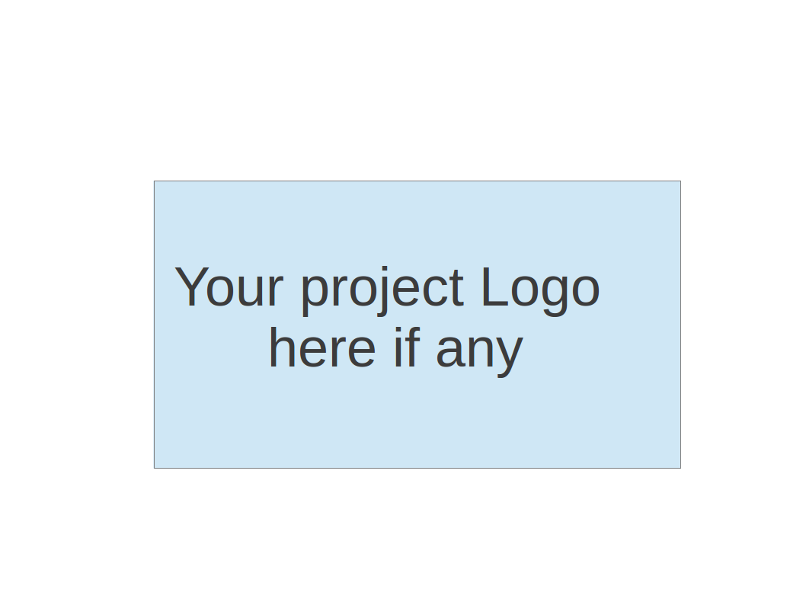

**Team 2 - Rental Ninja**

**Software Test Document**

| Team Member | Role(s) | Signature | Date |
| --- | --- | --- | --- |
| Yongjing Wu | Team Lead | *Yongjing wu* | 09/08/2024 |
| Jiacheng Ding | Security Lead | *Jiacheng Ding* | 09/08/2024 |
| Yueyang He | Design and Implementation Lead | *Yueyang He* | 09/08/2024 |
| Xueqi Zhou | Requirement Lead | *Xueqi Zhou* | 09/09/2024 |
| Rundong Zhong | Configuration Lead | *Rundong Zhong* | 09/08/2024 |
| Xiang Zhang | QA Lead | *Xiang Zhang* | 09/09/2024 |
|  |  |  |  |
|  |  |  |  |

**Revision history**

| **Version** | **Author** | **Date** | **Change** |
| --- | --- | --- | --- |
| **v1.0** | **Jiachen Ding** | **09/09/2024** | **initial** |
| **v1.1** | **Yongjing Wu** | **20/09/2024** | **Testing Summary** |

Testing Summary

Manuel Tests Reports

Automated Testing Reports

Testing Metrics

References

Glossary

# Testing Summary

## Test Objectives

* + - Verify that all essential functionalities are implemented correctly.
    - Ensure integration with other services is seamless.
    - Validate the security features of the platform.

## Test Criteria

* + - All test cases must pass without errors.
    - No critical or high-severity defects should remain unresolved.

## Test Scope:

* + - Unit Test
    - UI Test
    - API Test
    - Integration Test
    - System Test
    - Security Test

# Manual Testing Report

## Testing Case Sample:

***Test Case ID: TC0001***

Test Name: Test User Post API

New or Old: New

Test Items: post()

Test Priority: High

Dependencies: None

Preconditions: The database must contain project data.

Input Data: JSON payload with project details.

Test Steps:

Send a GET request to /apiv1/rental_nijia/post.

Postconditions: The response should contain a success.

Expected Output: A JSON array of responses.

Actual Output: None

Pass or Fail: Pass

Bug ID/Link: None

Additional Notes: None

## Testing Report Form:

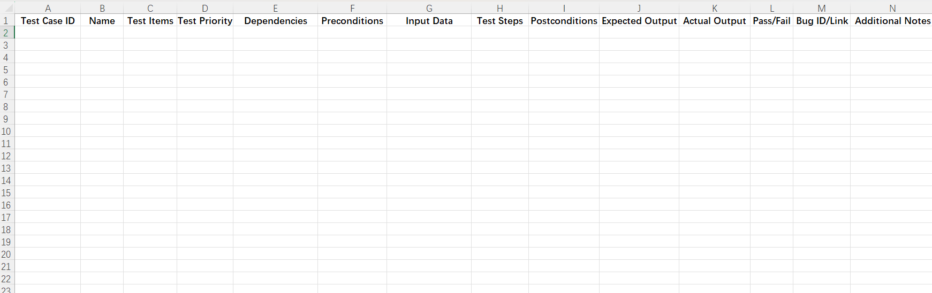

# Automated Testing Report

Unit Tests: JUnit for backend tests and Jest for frontend components.

Integration Tests: Postman for API testing.

E2E Tests: Cypress for testing the complete user flow.

# Testing Metrics

Number of test cases: 20 test cases

Test coverage: 85% code coverage

Defect rate: 5%

Resolution rate: 100% of identified defects were resolved.

# References

# Glossary